**Issues with Celia’s InventoryManagementSystem2.sln:**

(InventoryManagementSystem.sln stopped working after a while, perhaps because I tried to rename .cpps to .ixxs. Looks like module/header files must start as .ixx to be properly compiled. This seems to have worked for InventoryManagementSystem2.sln.)

Up until a certain point “import <json.hpp>;” worked and the specialization file was fine; then I noticed red squigglies and tried at least half a dozen things (including Quin and Gemini’s suggestions) to no avail. The only thing that made the errors go away was reverting to an #include. Decided to forge on.

Also, got an error message that there’s something wrong with IntelliSense (visible in screenshots below)—seems specific to InventoryProcessor_Product.ixx. Attempted a few fixes to no avail and tried creating a new file, InventoryProcessor_Product2.ixx, copying over the code, deleting the original file, saving all, cleaning and rebuilding—to no avail. Still saw IntelliSense error message. Decided to forge on.

Then the program worked at 2:58 AM – see summary.json

Then broke (I don’t know how):

3:53 after saving all, cleaning and rebuilding, restarting VS:

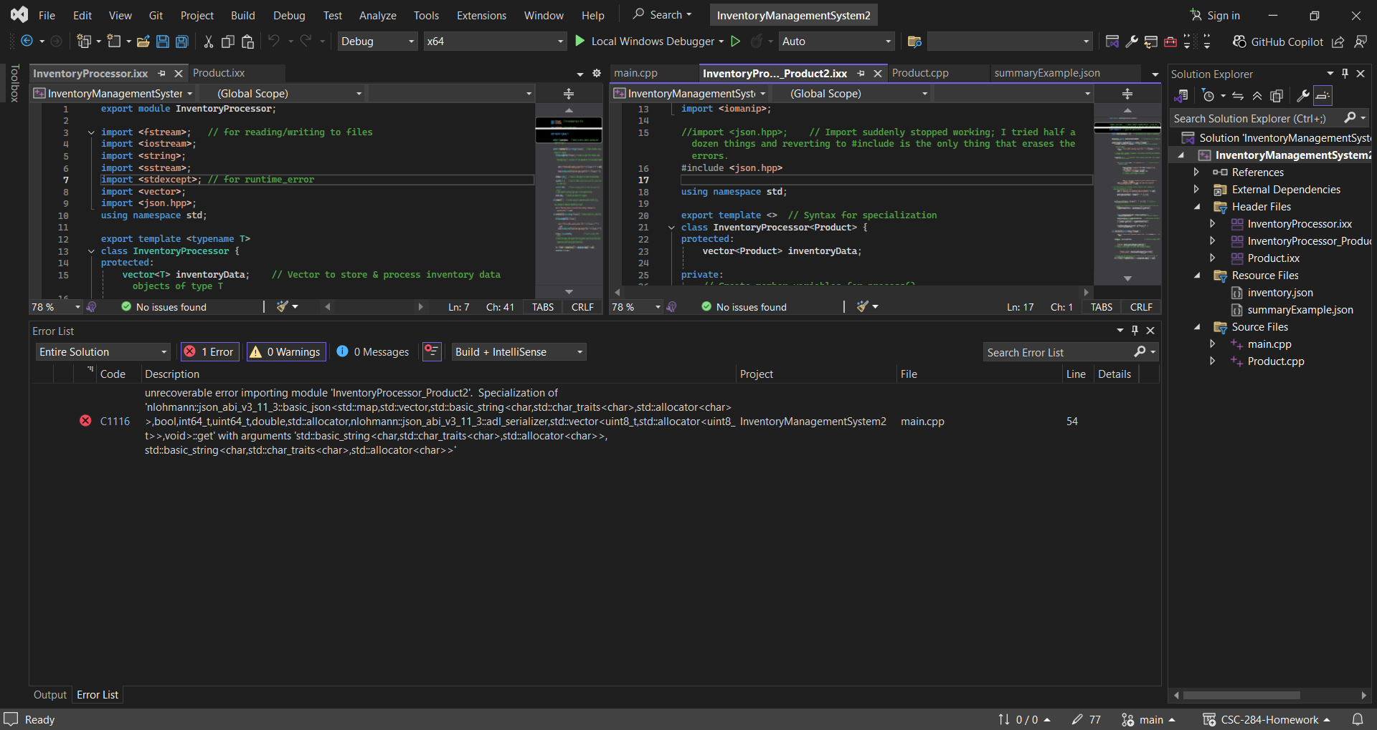

3:54 after clean & rebuild:

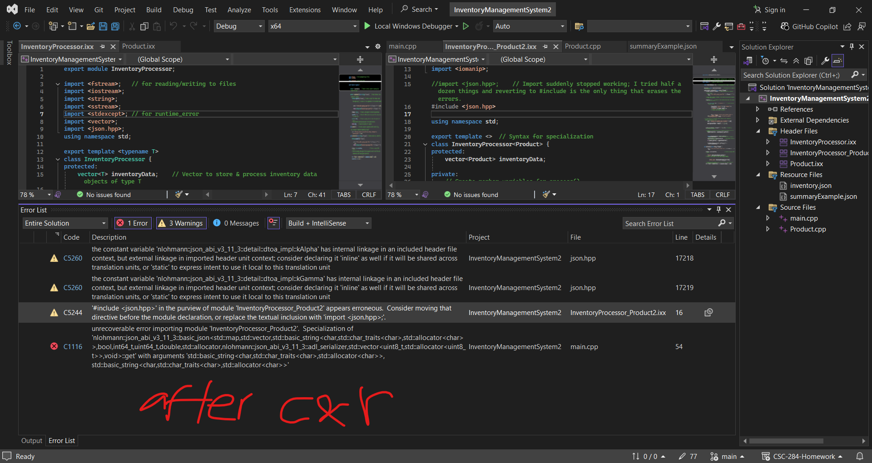

Tried to follow the instructions in the warning.

Importing JSON again created more errors so I undid that.

Putting #include <json.hpp> at the very top of the specialization file at first showed other errors, but then…

It worked again at 3:59 AM – see summary2.json

4:01: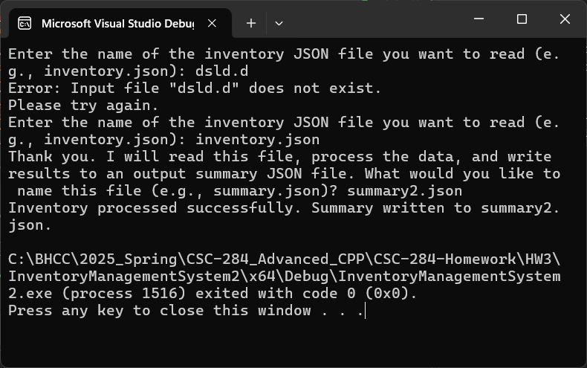

4:03: Note that IO formatting does not work in summary2.json

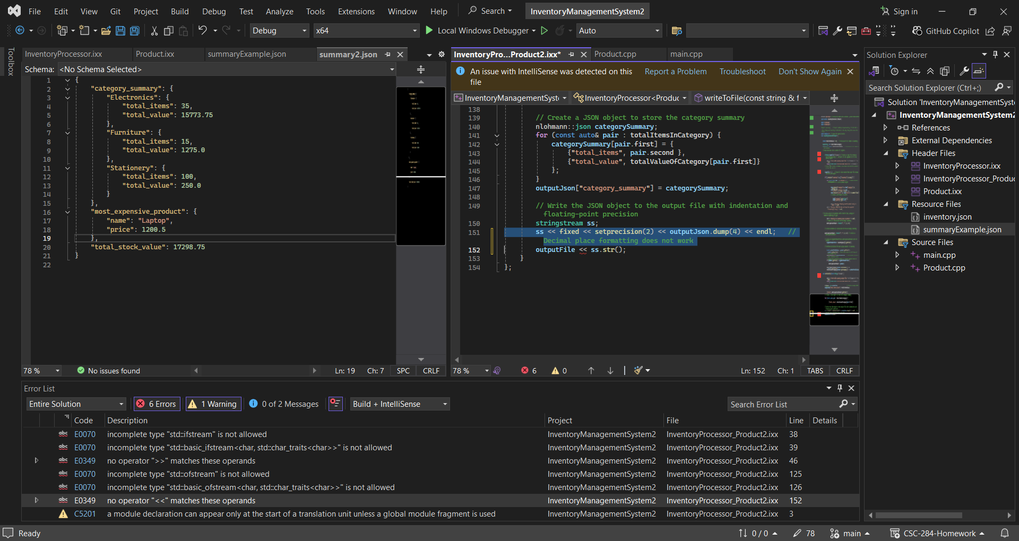

Solution properties:  
